EXPERIMENT-3
Aim
To develop a cloud-based Property Buying/Rental Application using Zoho Creator that allows users to search, buy, or rent properties in Chennai online.
Software Used
- Zoho Creator
- Web Browser (Chrome/Edge)
- Zoho Cloud Platform
Algorithm
- Open Zoho Creator.
- Create a new application named Property Buying/Rental System.
- Add the required fields.
- Enter customer and property requirements.
- Click Submit.
- Store details in the cloud database.
- Display matching property requests and customer details.
Output:
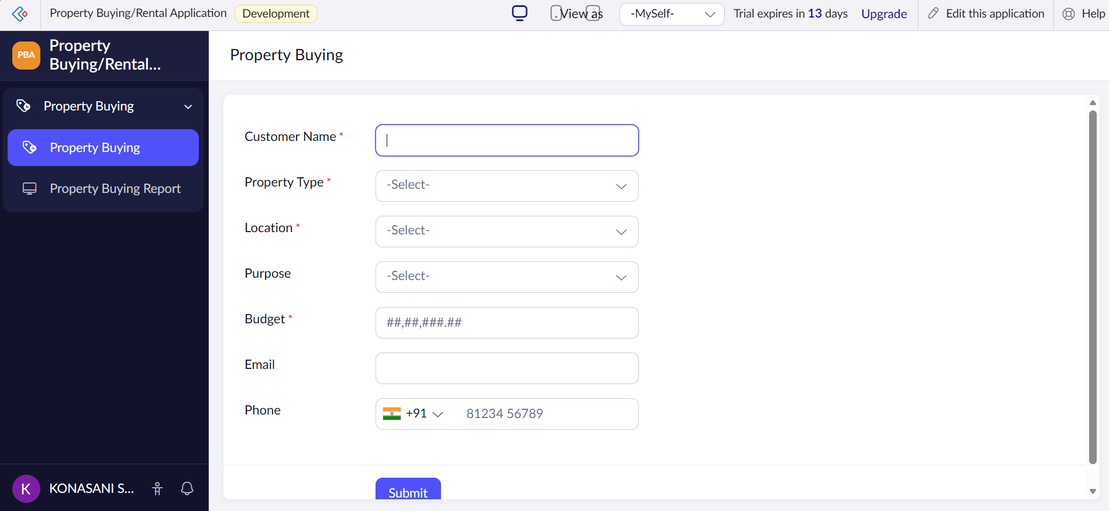
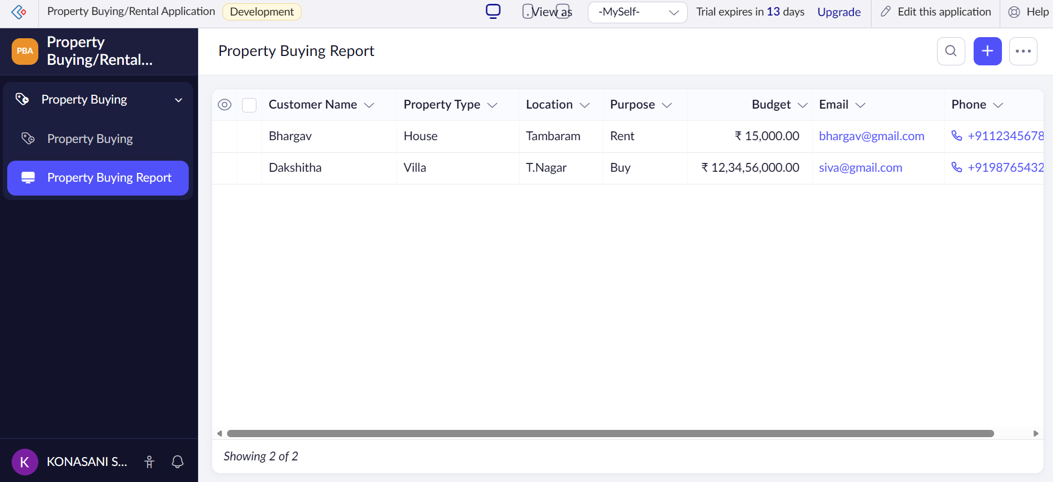

Result
The Property Buying/Rental Application for Chennai was successfully developed using Zoho Creator SaaS. The application allows users to submit property requirements online and stores the details securely in the cloud.

